## Implementing CRM For Result Tracking Of A Candidate With Internal Marks

1. **INTRODUCTION:**

OVERVIEW:

The administrator should be able to create all base data including Semester, Candidate, Course and Lecturer , Lecturer should have the ability to create Internal Results, Dean, who is one of the Lecturer, should be the only one with ability to update Internal Results, Re-evaluation Can be initialized by Candidate for all Internal Results. Now only dean can update the marks after re- evaluation.

PURPOSE:

This project aims to be a one stop solution for Result management system. The purpose of this project is to manage the college’s student results based on their course and applicable semester. This helps student results tracking easier and saves time. The look and feel of the tool is user friendly and shows real time data in form of reports and dashboards.

1. **RESULTS:**

|  |  |
| --- | --- |
| OBJECT NAME | FIELDS IN OBJECT |
| SEMESTER | |  |  | | --- | --- | | Field Label | Data Type | | Semester Name  Course(Lookup) | Text  Text | |
| COURSE DETAILS | |  |  | | --- | --- | | Field Label | Data Type | | Course Name | Text | | Course ID | Text | |
| INTERNAL RESULTS | |  |  | | --- | --- | | Field Label | Data Type | | Candidate ID | Text | | Course ID | Text | | Marks | Text | | Candidate(Lookup) | Text | |
| CANDIDATE | |  |  | | --- | --- | | Field Label | Data Type | | Candidate Name | Text | | Semester Name(Lookup) | Text | |

### Creation Salesforce Org

### A new developer sandbox was created for this project.

### 

### 

1. **OBJECTS**

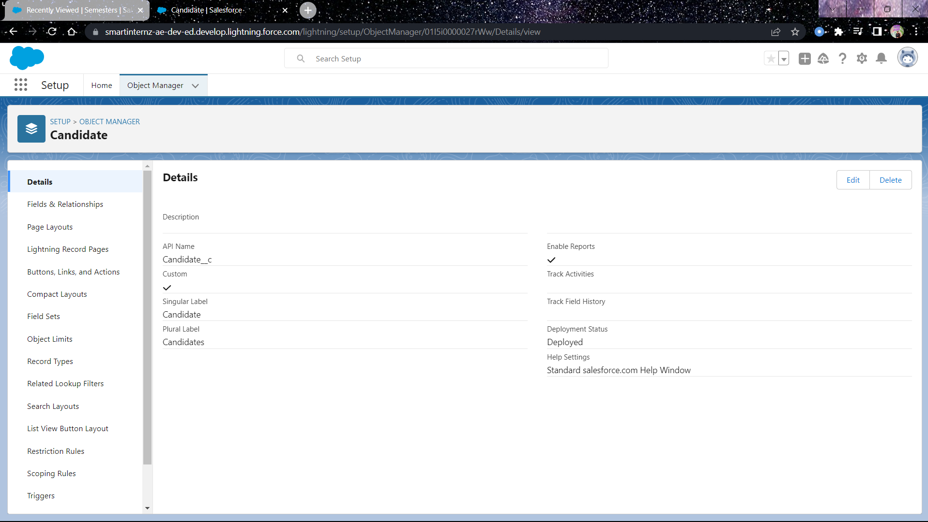

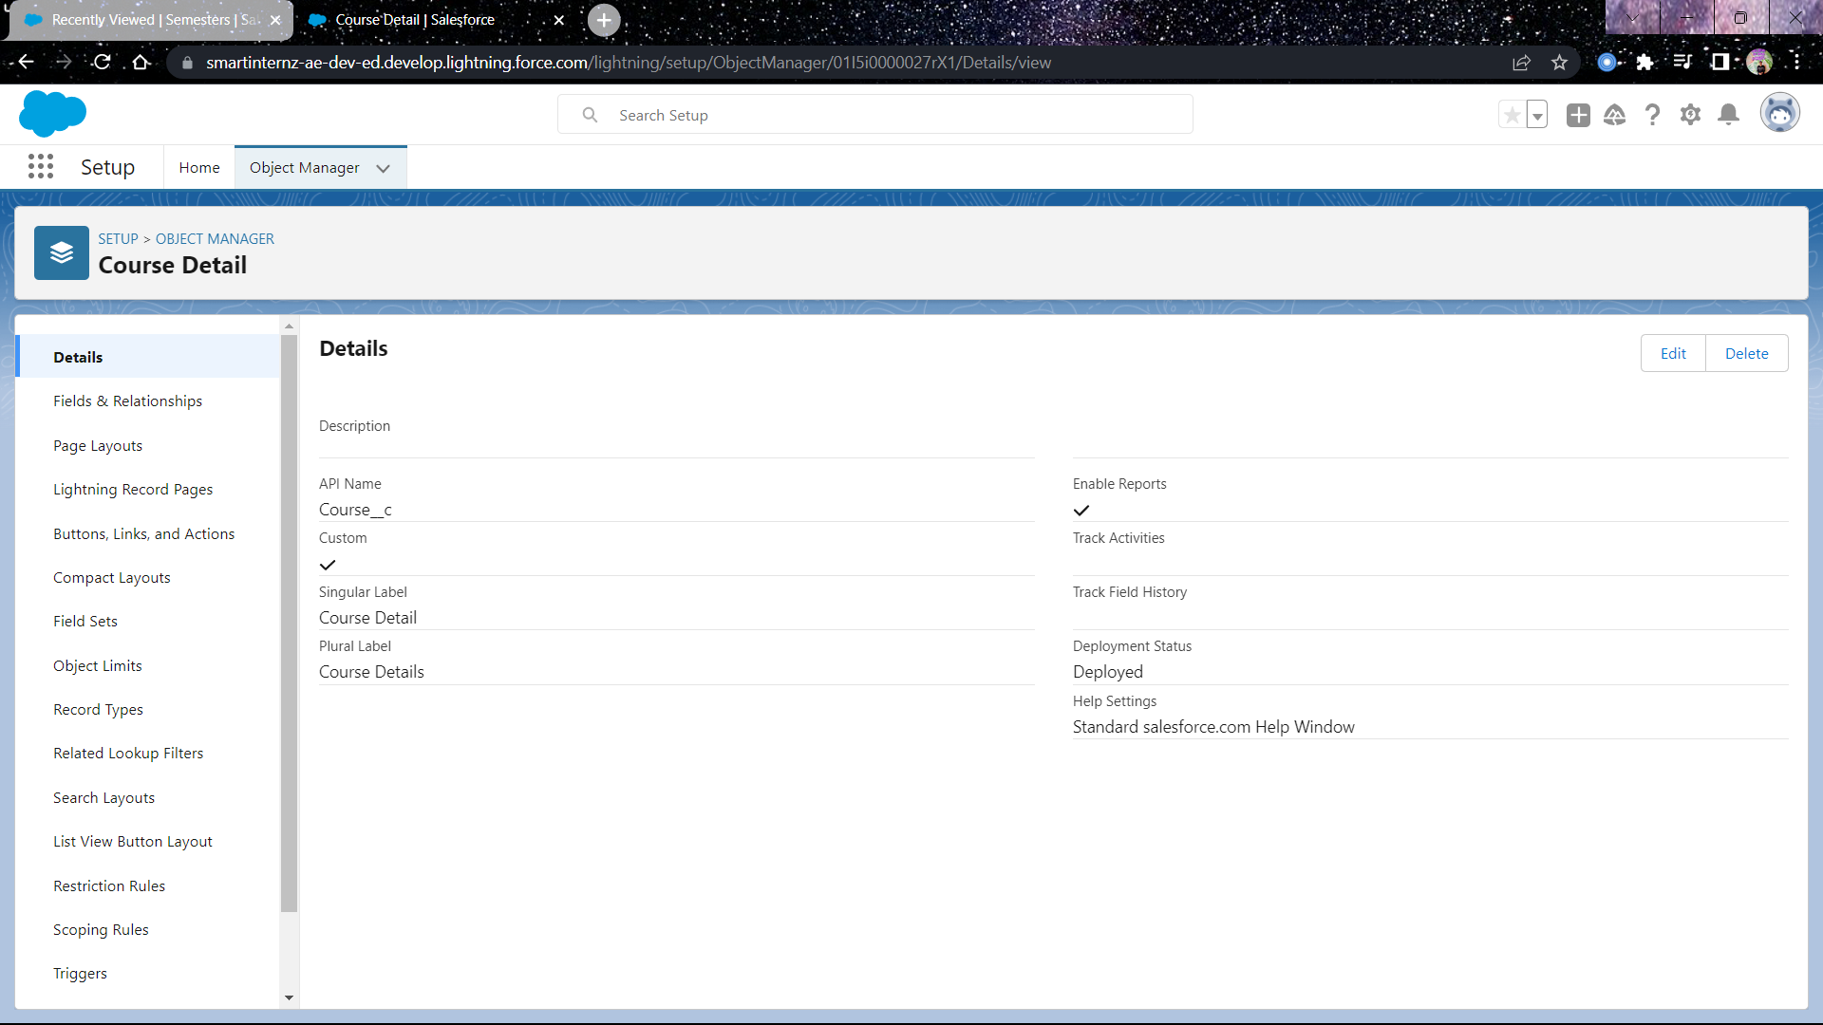

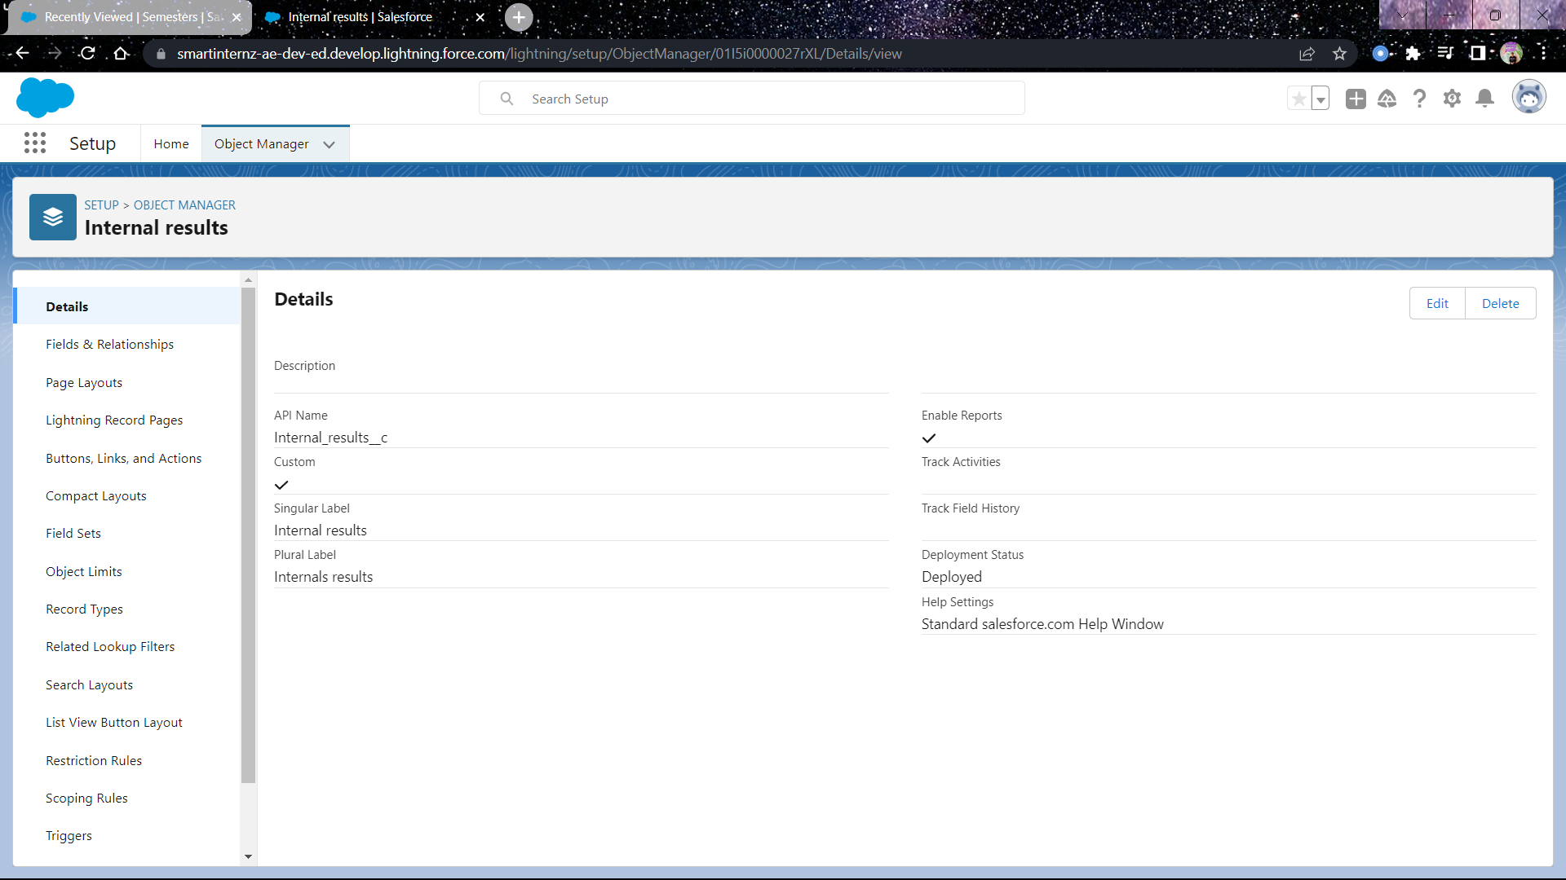

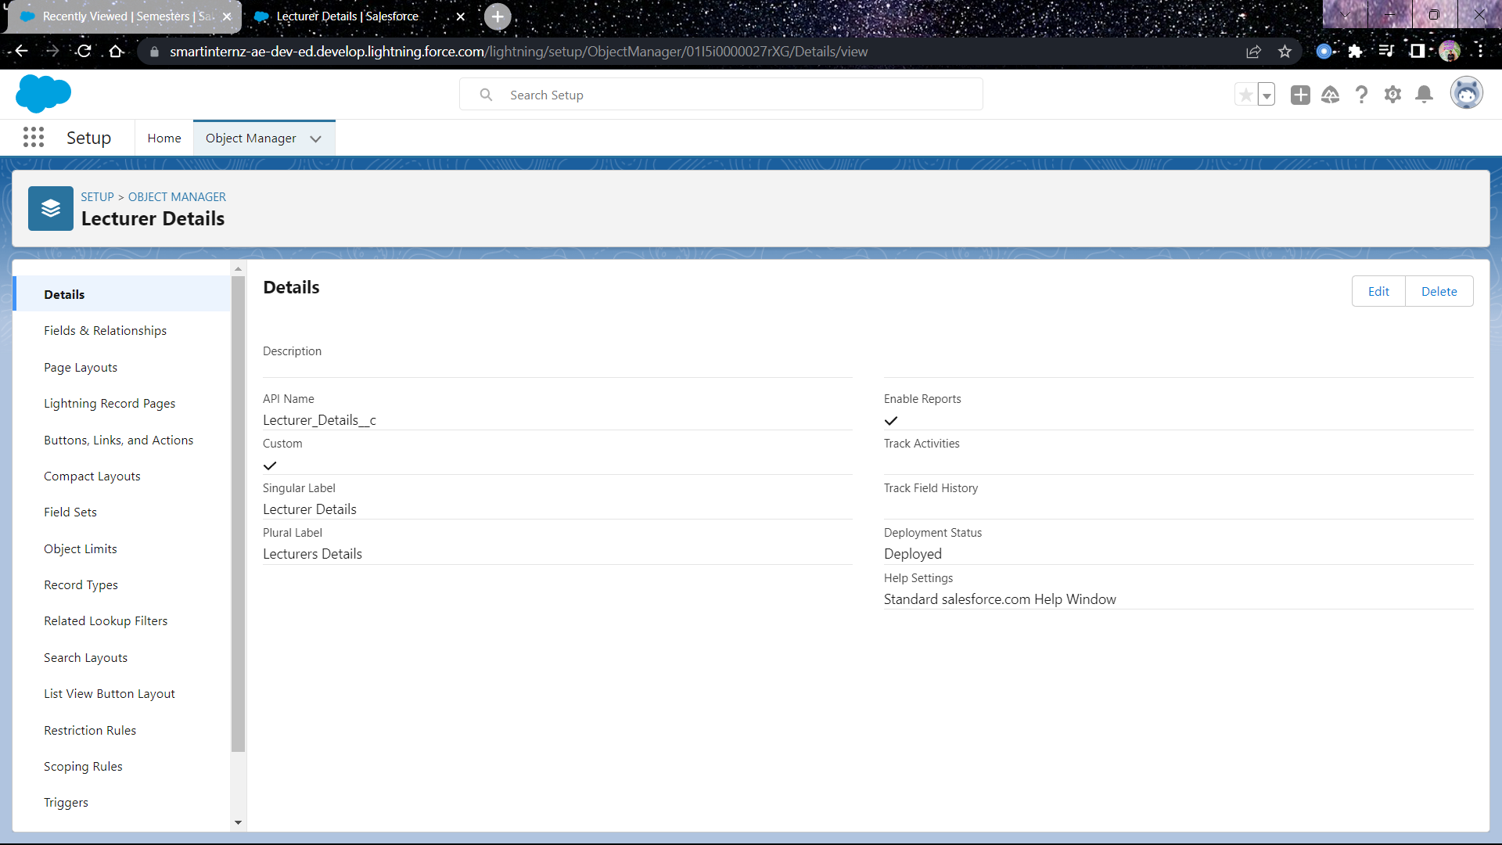

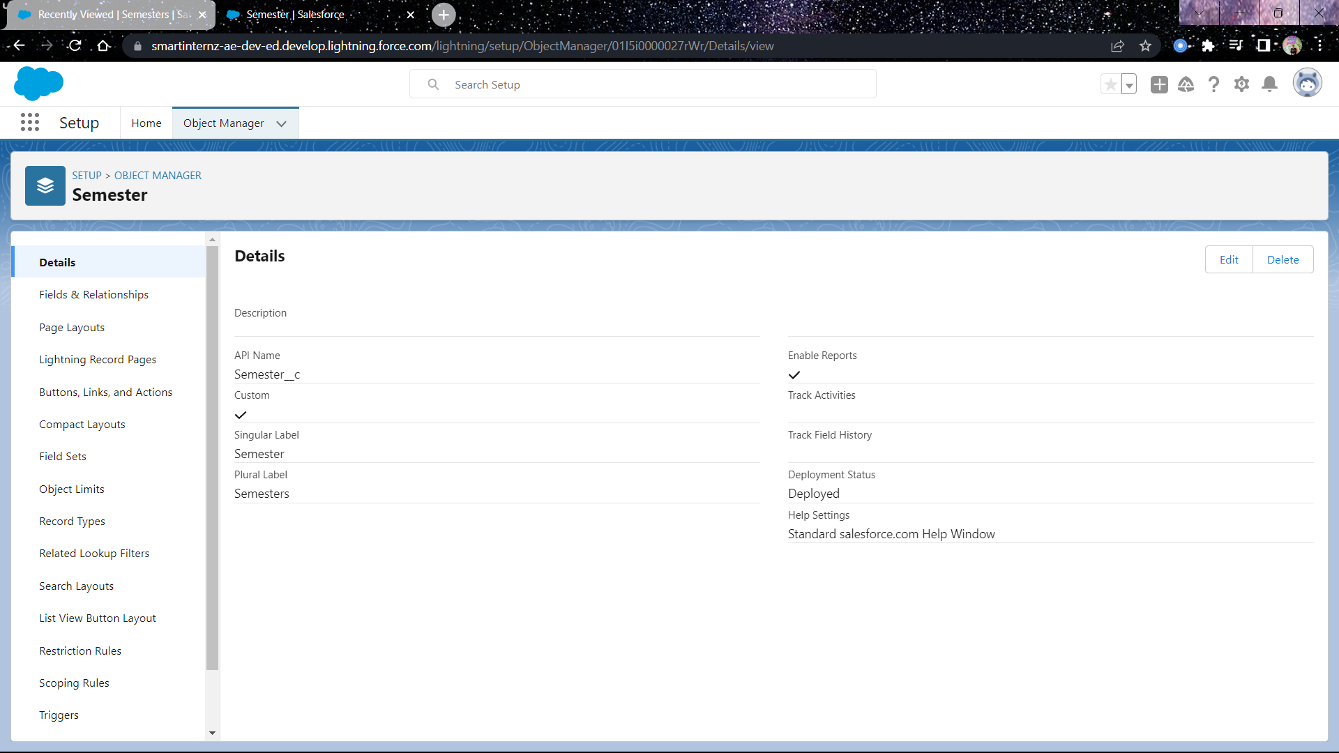

A total of 5 objects have been created namely **Semester**, **Candidate**, **Course Detail**, **Internal Marks**, **Lecturer Details**.

1. **TABS**

Custom tabs have been created for ease of accessibility on the lightning app for each object and their records.

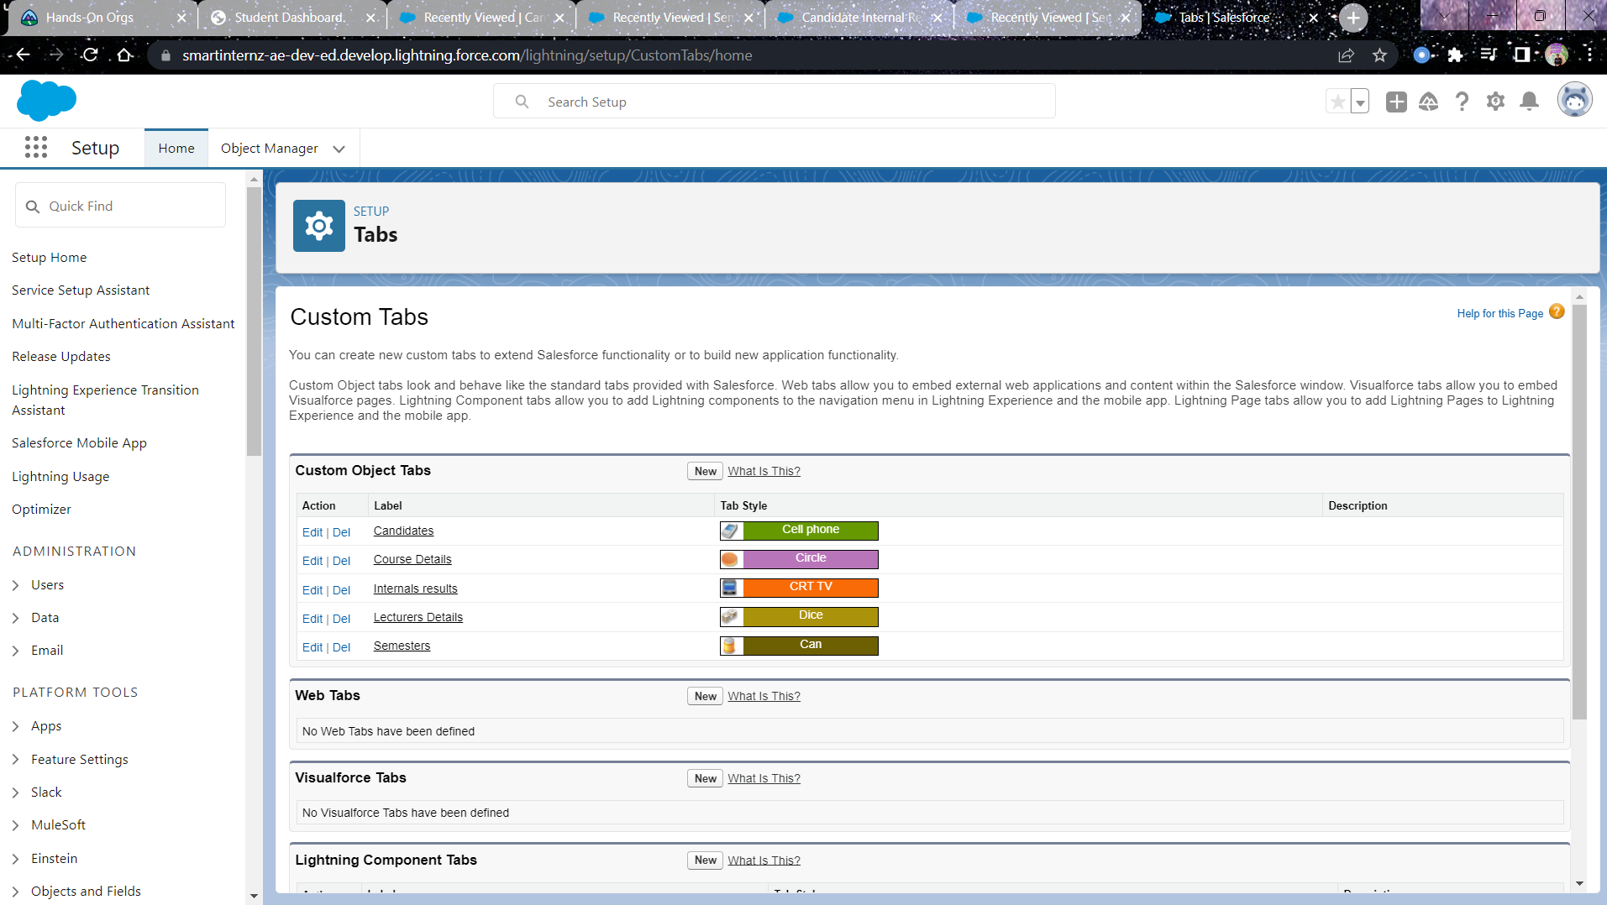

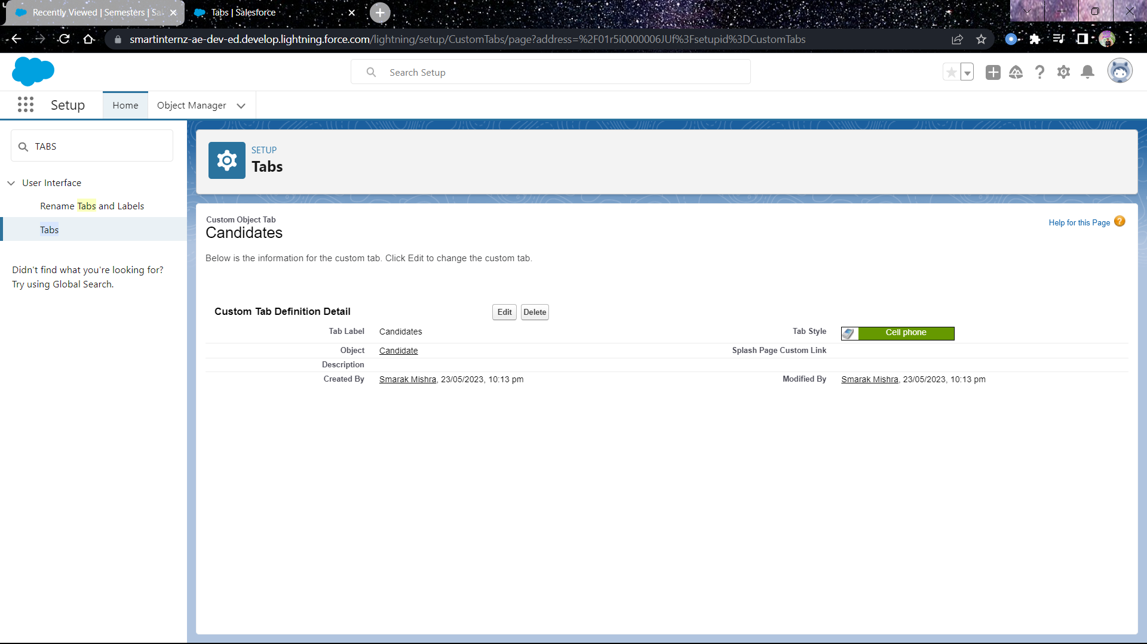

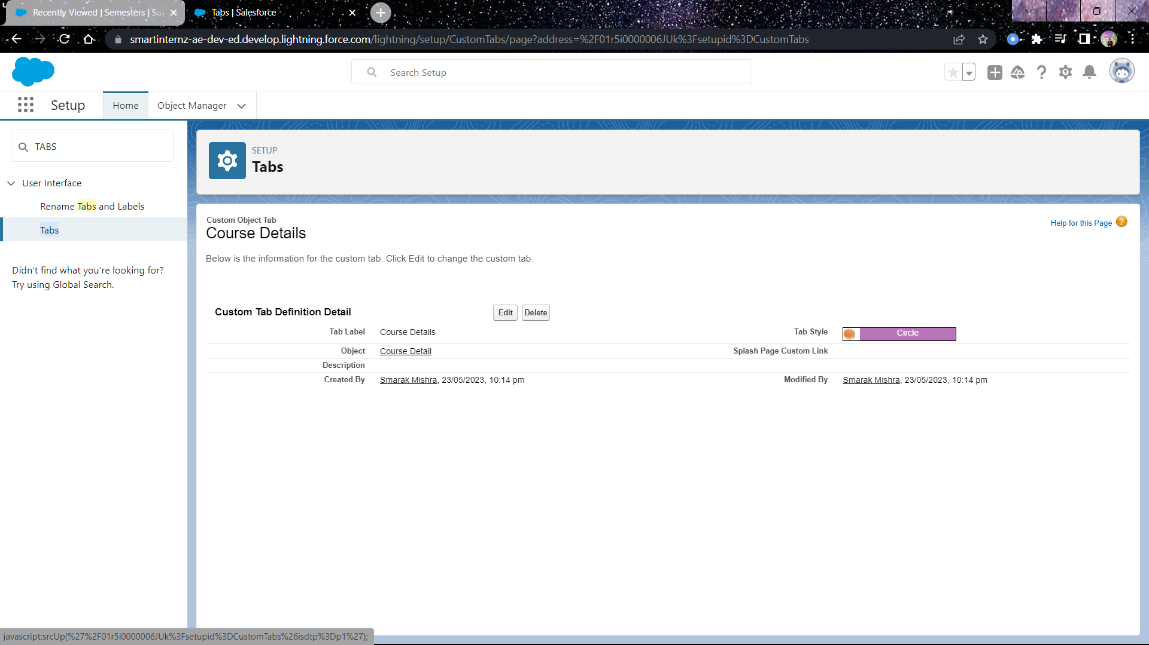

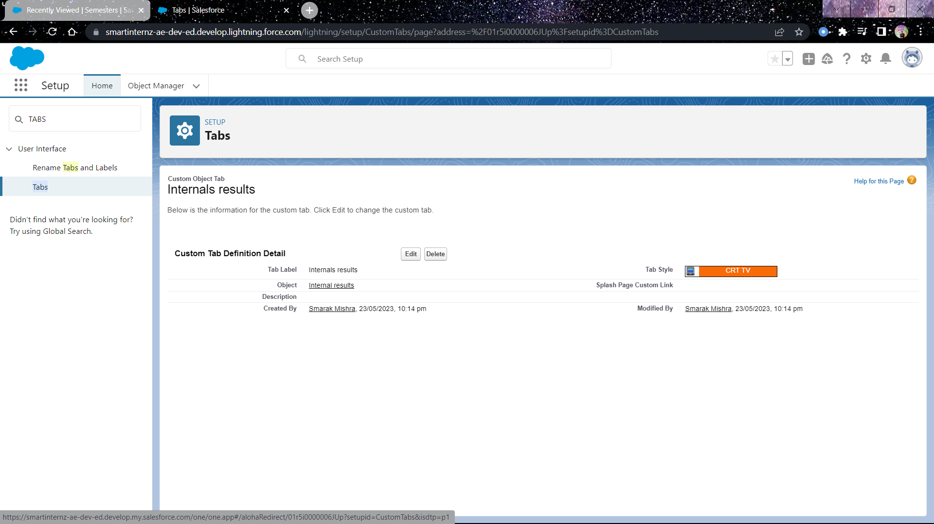

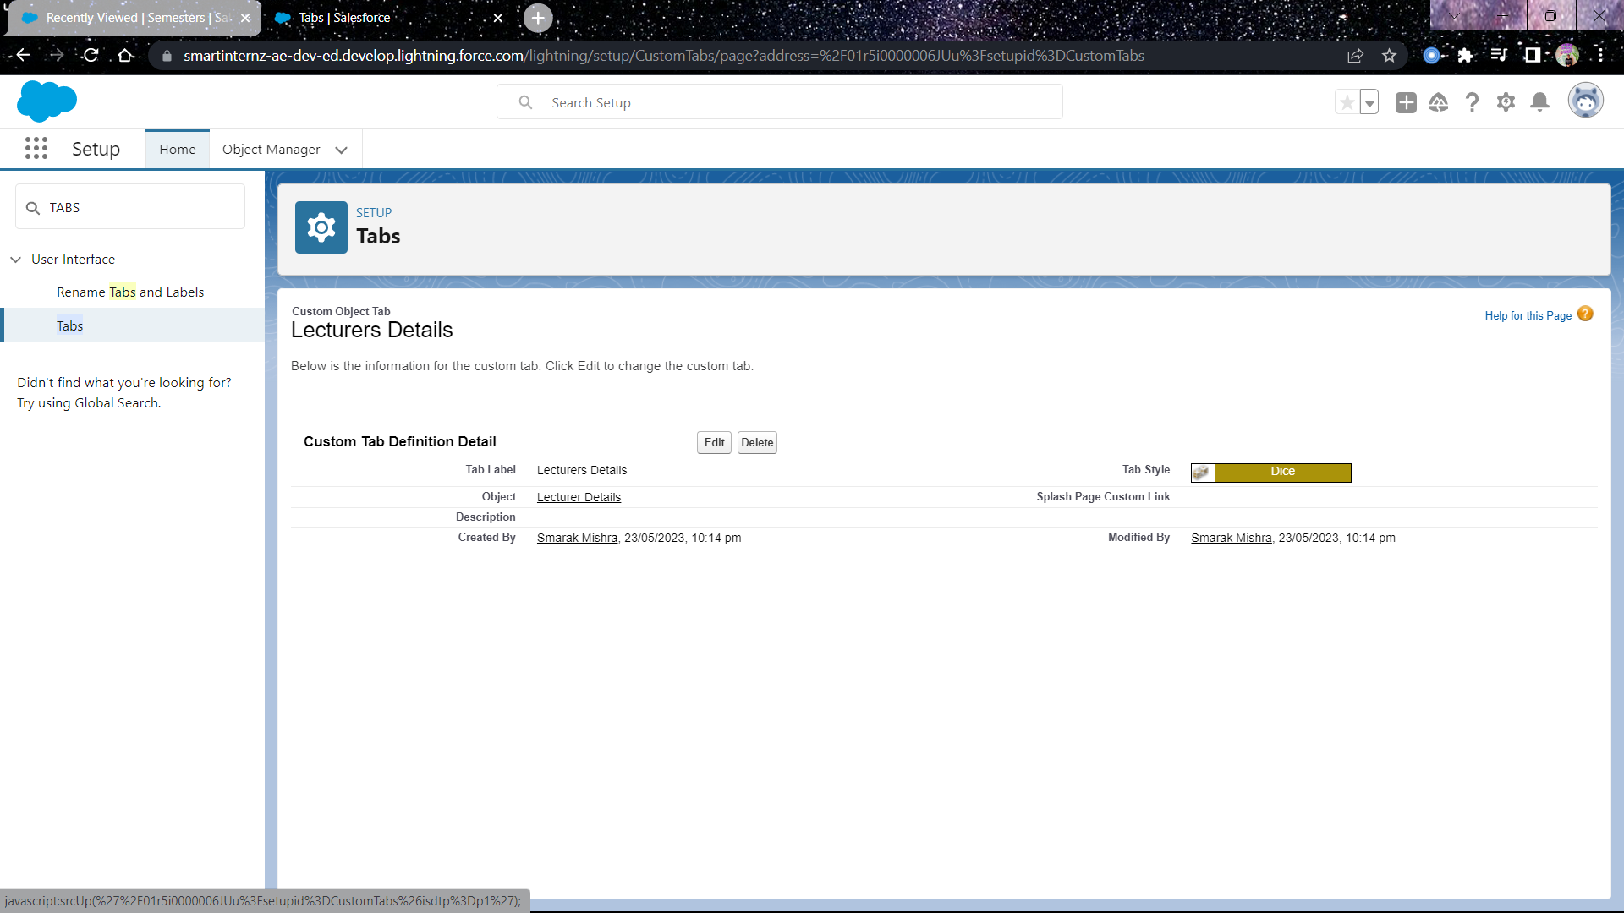

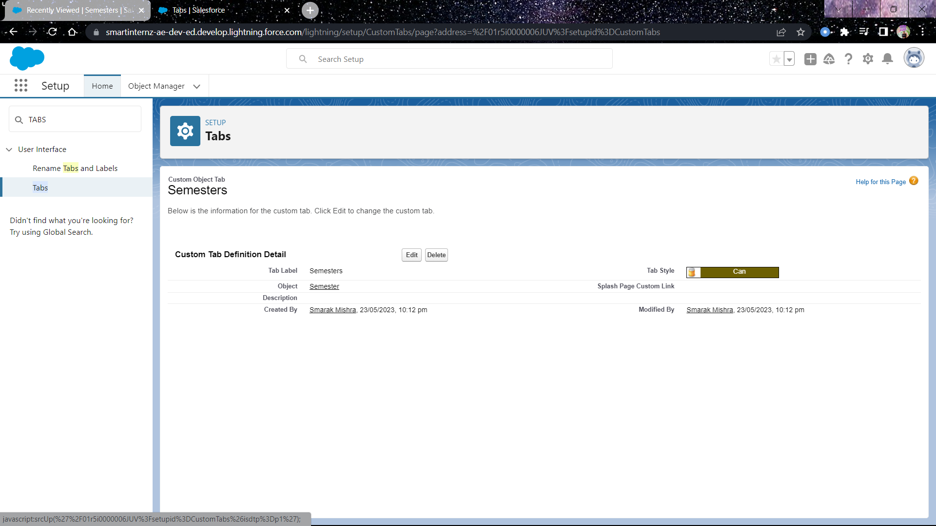

1. **LIGHTNING APP**

A dedicated app has been created for the Result system. It contains the relevant tabs.

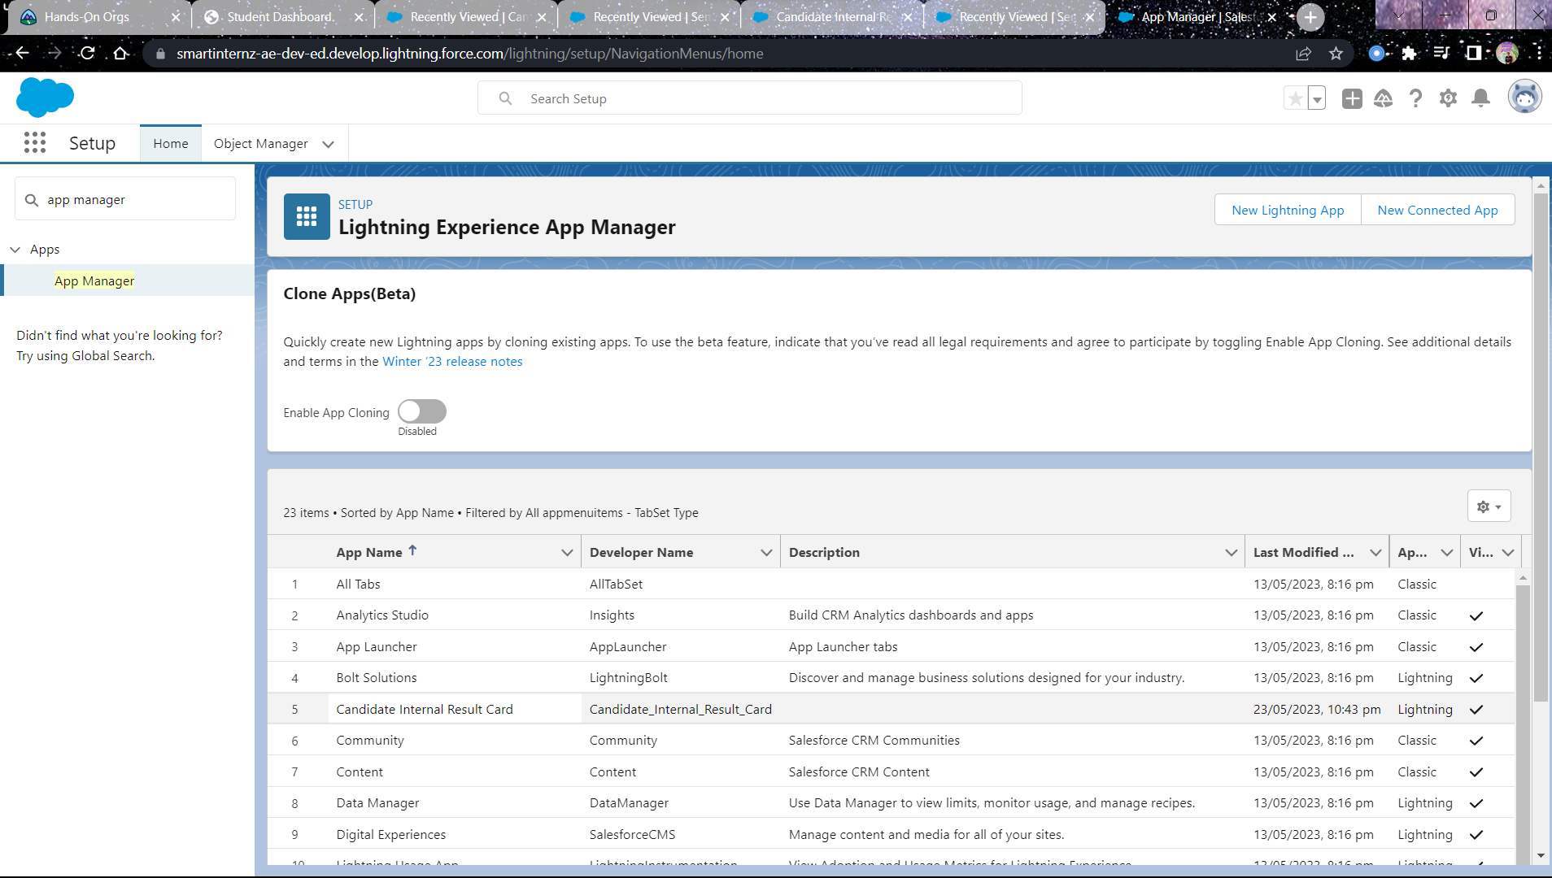

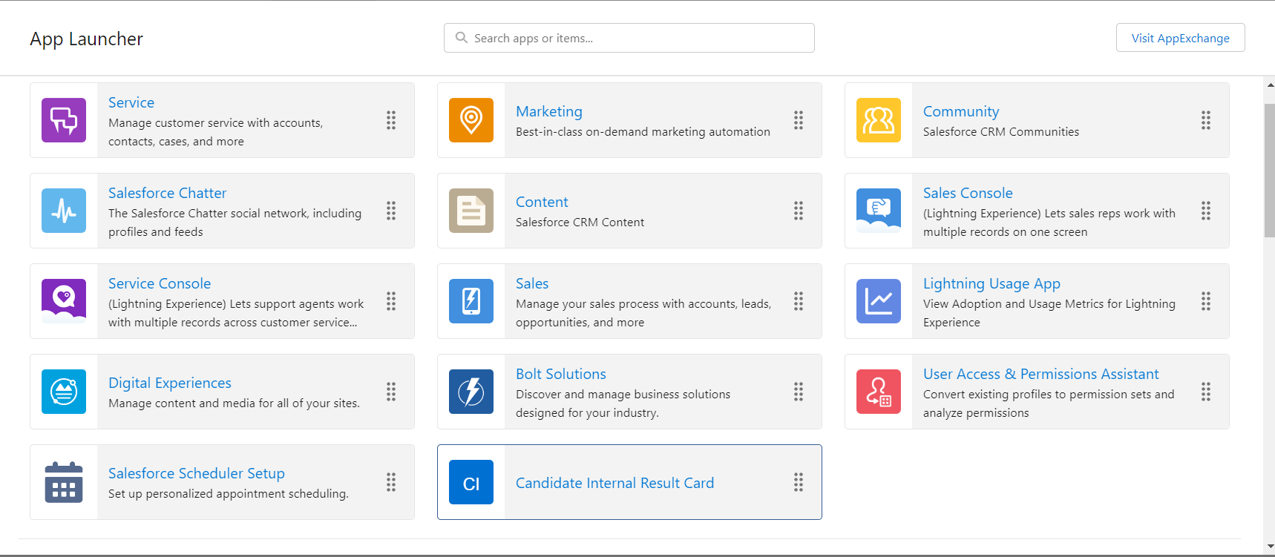

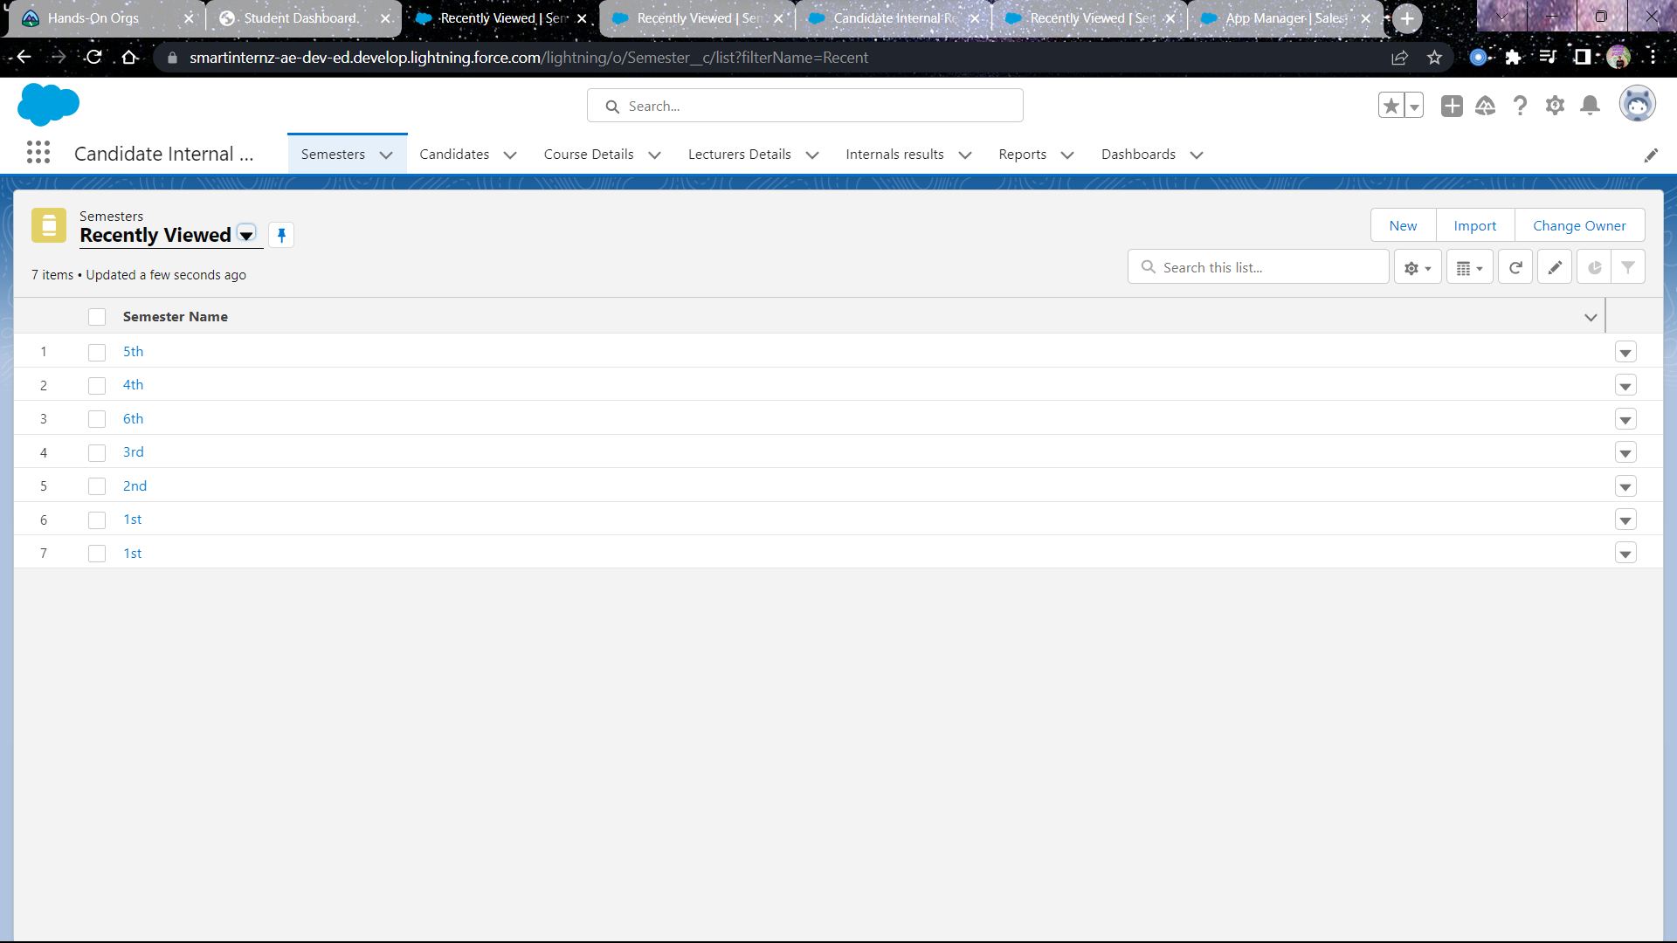

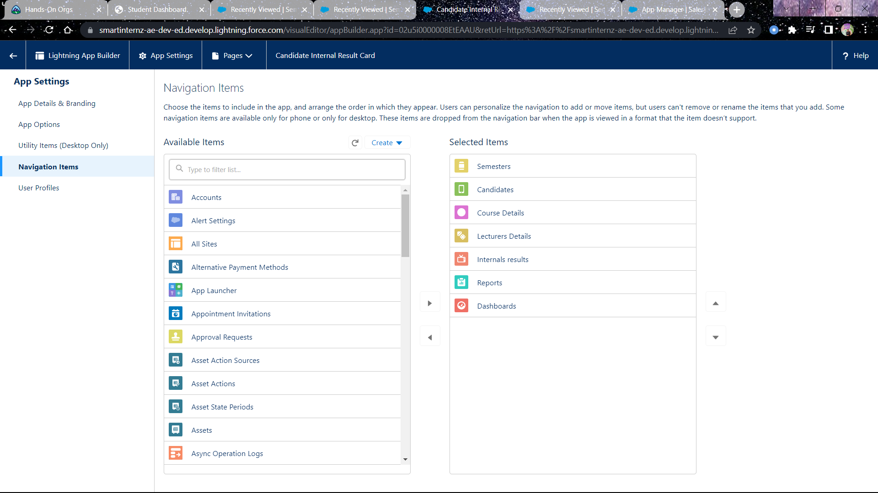

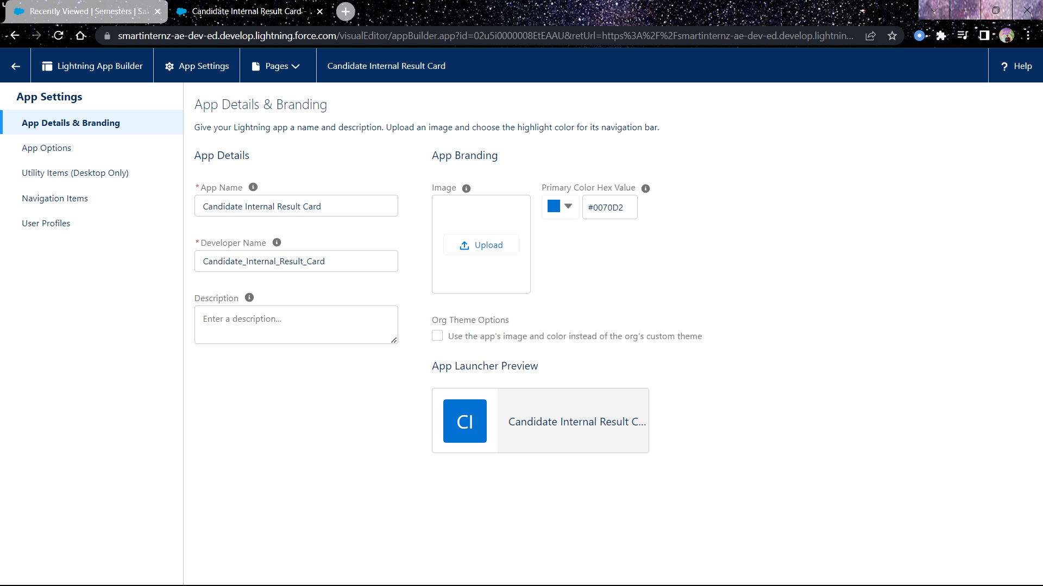

1. **USERS**

A user was created **Class Teacher** who can enter marks for students in the system.

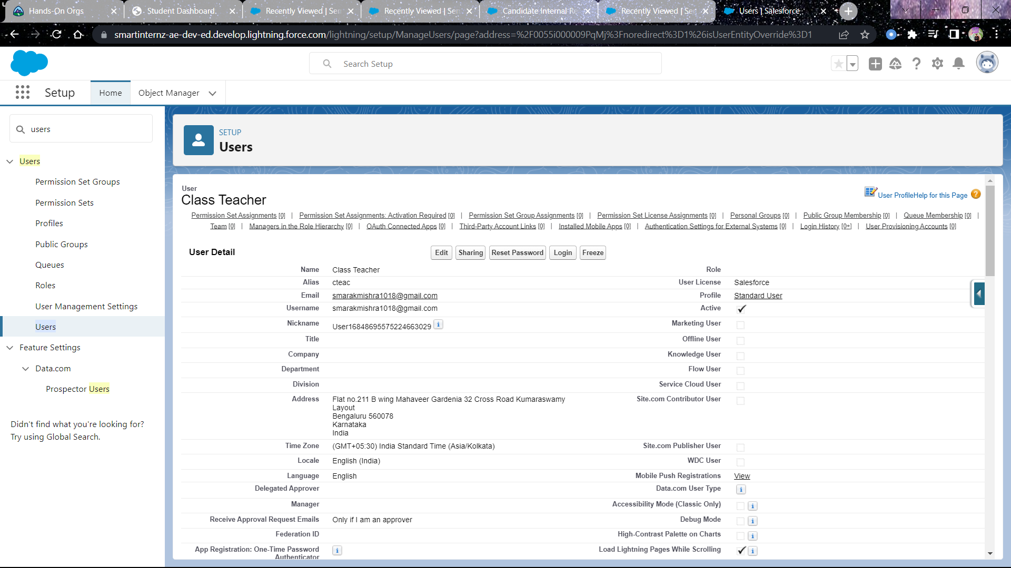

1. **REPORTS**

A report has been created to monitor and track course wise and duration wise data.

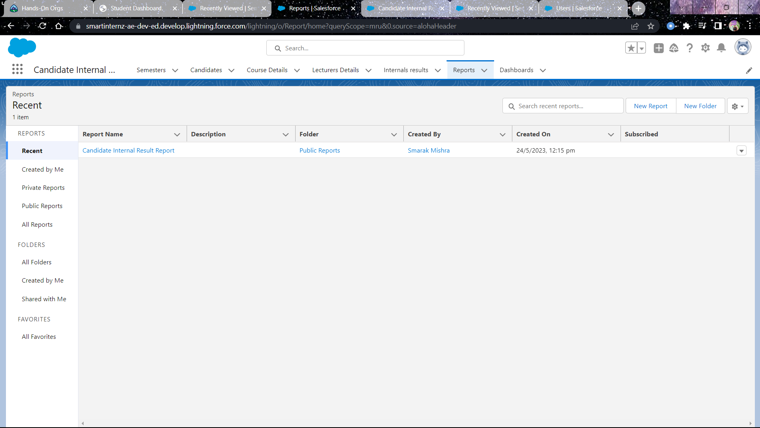

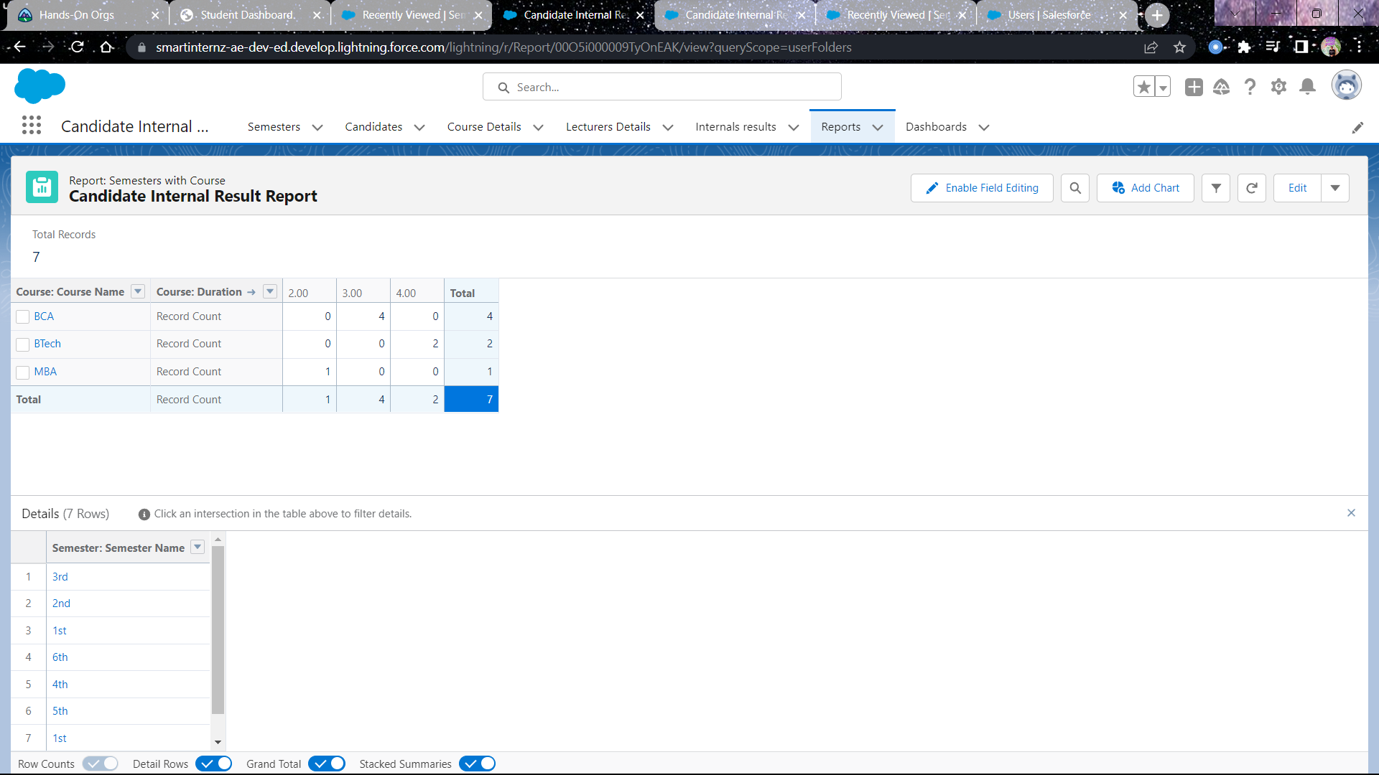

1. **DASHBOARDS**

A dashboard has been created where the report is embedded.

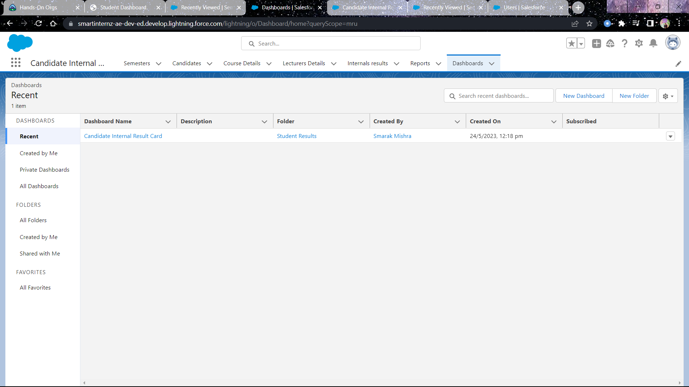

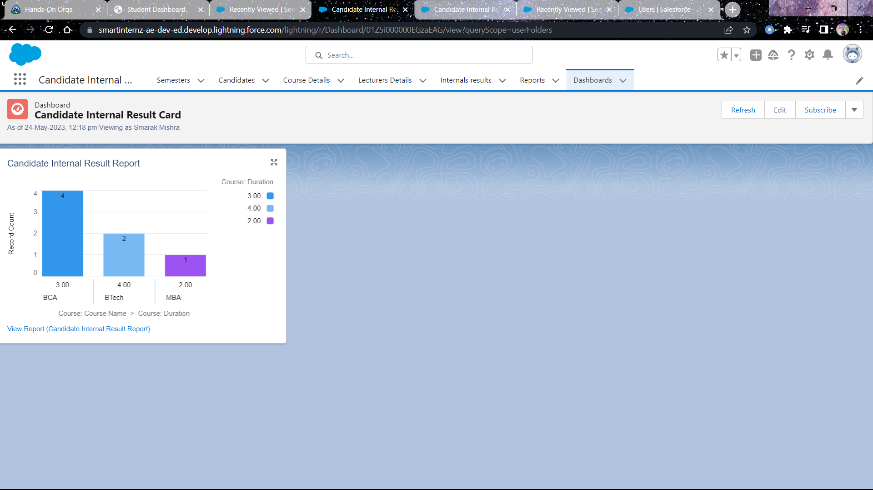

1. **ACCESS DETAILS**

As the user **class teacher** has been assigned with standard user profile which is a standard profile so a new permission set has been created to give access of the concerned object to the user.

In the permission set object access has been given for creating records for semester, candidate, internal details, course details etc.

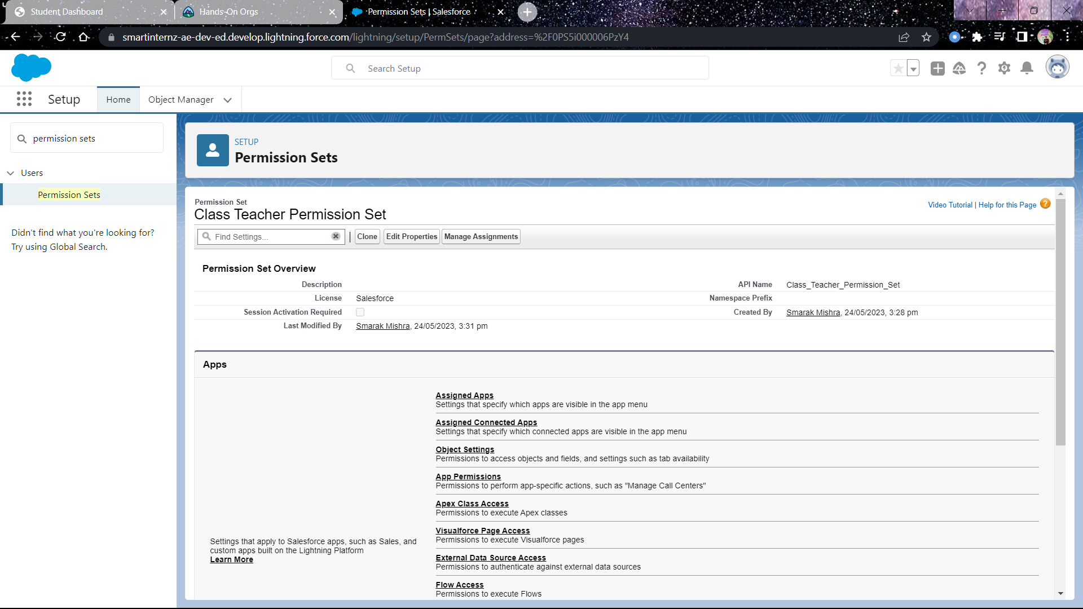

**Class Teacher** user has been assigned with Standard user profile which is a standard profile and cannot be edited to add object permissions.

So a new permission set has been created namely **Class Teacher permission set**, which is assigned to the Class Teacher user.

In this permission set, the concerned object access has been added so that the class teacher user can create data.

Also the profile standard user has been added to the lightning app for visibility.

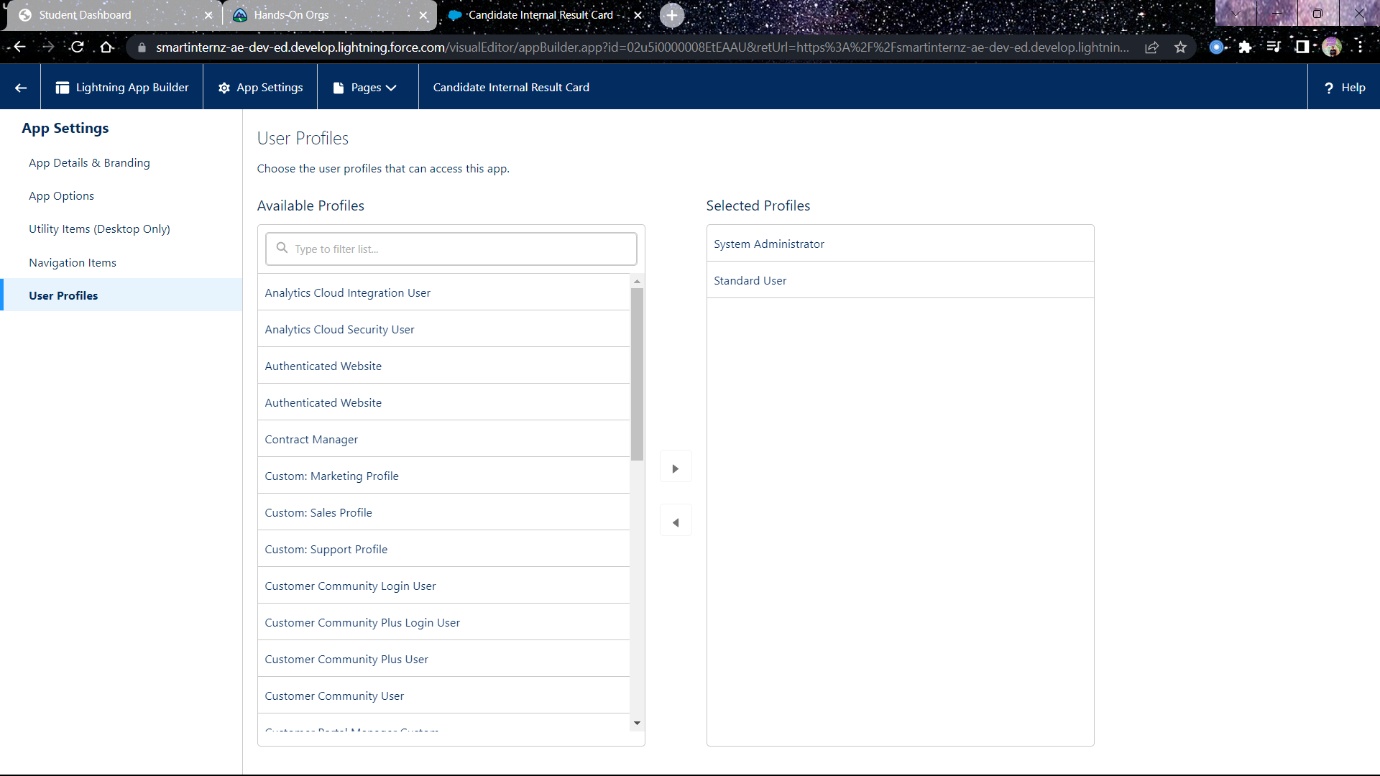

**TRAILHEAD PROFILE PUBLIC URL**

Trailhead Profile: [**https://trailblazer.me/id/smarak1810**](https://trailblazer.me/id/smarak1810)

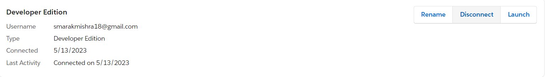

1. **ADVANTAGES & DISADVANTAGES of THIS CRM**

Advantages:

* Allows for the consolidation of customer data and the basis for deep insights.
* Speeds up the sales conversion process.
* Increases staff productivity. Lowers the cost.
* Improves customer experience by allowing personalization and improved query resolution.

Disadvantages:

* CRM may not be suitable for all businesses.
* Requires process-driven sales organization.
* Security and data protection issues for centralized data.

1. **APPLICATIONS**

* Target Marketing
* Can work easily.
* Increases candidate quality.

1. **CONCLUSION**

Student internal mark management system deals with student details, academic related reports, college details and course details.

It tracks all the details of the student from day one to the end of the course which can be used for tracking the progress of any said student.